18th January 2022
Ref: 220118/AWX/JLH

Year group Remote Learning Provision – Year 12 Level 3 learners
Wednesday 19th January – Friday 21st January

Dear Parents/Carers,
Unfortunately, due to rising staff absences, Year 12 Level 3 learners will be asked to learn from home for the remainder of this week. They should remain at home for the next 3 days, and access their lessons through Microsoft Teams. Staff in school will be online offering live lessons, and learners should follow their usual timetable for these 3 days. Any learners who have external exams should attend school for these.
Year 13 will attend school and access all their lessons as normal with staff.
Year 12 Access learners will attend school, but will undertake remote learning through Microsoft Teams in a supervised study area.
All exams will continue as timetabled and all learners should attend for their exams as per their timetable.
With the current high rates of Covid-19 amongst staff and learners, we continue to take advice from the local authority, and ask that you ensure that your child does not attend school if they have any symptoms of Covid-19, however mild, and encourage them to undertake regular lateral flow tests.

Kind regards
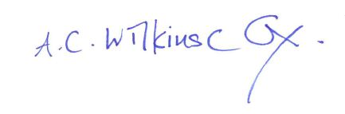
Ann Wilkinson-Cox.
Assistant principal for Key Stage 5.

