







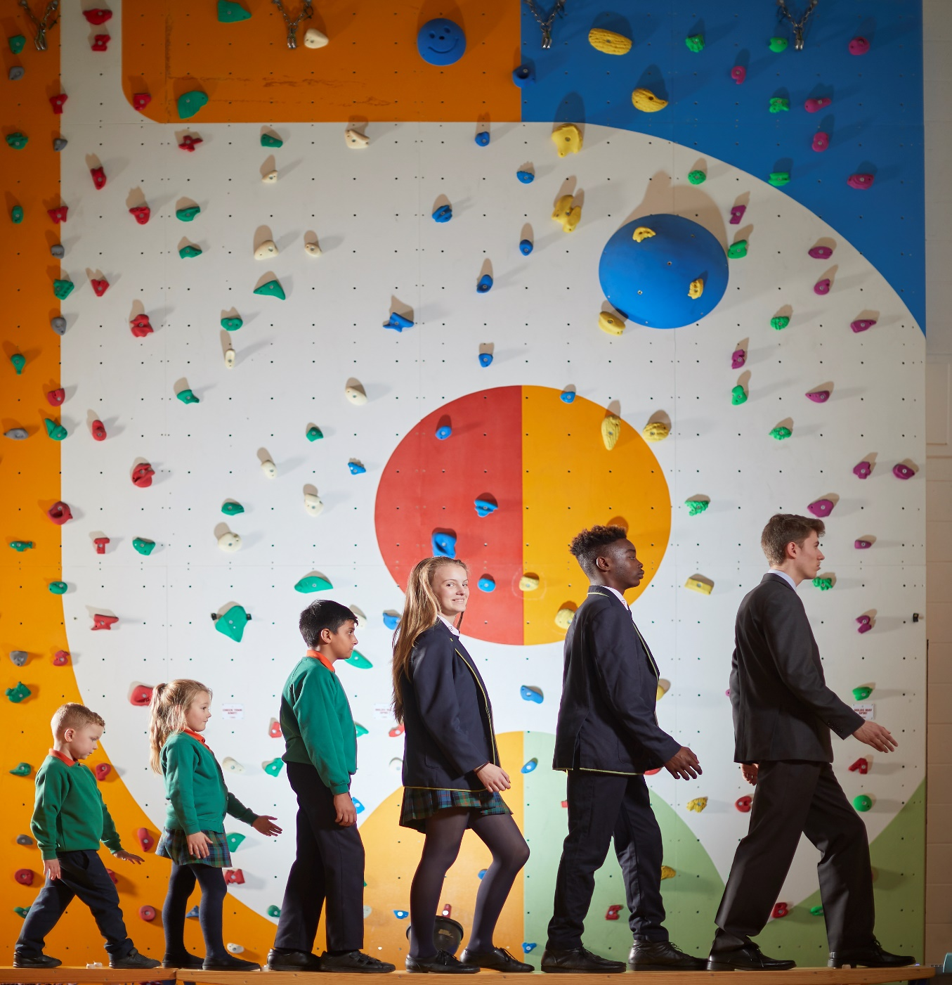



Contents

• Letter from Executive Principal

• Job Description

• Person Specification

• Information for Applicants

Dear Applicant,
Thank you for your interest in working at Bradford Academy.
We are clear in our vision:
Known by God
Valued as unique
Understood and accepted
Guided to be the best we can be
We are a shining light in our community
Using opportunities to change our lives and those of others
“A city on a hill cannot be hidden”
Our mission is to make a difference.
Are you ready to change your life and those of others? If so, Bradford Academy is an exciting place to make a difference.
We are a “Good” school, as recognised by Ofsted in both 2013 and 2017. When you visit us, you will see the impact our passionate and ambitious staff have on child from age 2 years old to 18. Every aspect of our provision; Early years, Primary, Secondary and Post 16 is good, and we are rightly proud of the difference we make every day to the lives of over 1800 young people in Bradford. You can read our full report on the Ofsted section of our website.
As a Church of England Academy, we believe that a commitment to developing the faith and spirituality of our learners is of vital importance when working at the academy. Our moral purpose guides us to ensure that every learner can be the best they can be spiritually and personally as well as academically. We believe that we make a difference not only within but out in the local community. This was recognised by being awarded a TES award for Community and Collaboration.
We have two resourced provisions in our Secondary Phase (DSP); one for Physical Disability and one for Autism. This reflects our passion for creating a truly inclusive school that reflects society and develops compassionate, understanding children and young people.
Staff who work at Bradford Academy benefit from support, challenge and investment. We understand how valuable our staff team are and strive to give them all the tools they need to excel in their chosen field. As a member of our team, you will benefit from CPD that was recognised as exemplary, receiving a Platinum level Professional Development Quality Mark from University College London. We value our staff’s wellbeing and believe that Bradford Academy is an exciting and worthwhile place to work.
If you feel you share our vision for improving the lives of young people and have the tenacity, resilience and commitment to be a part of our journey then submit your application or contact us to arrange a visit. We would love to get to know you better.
Yours sincerely
Mrs Mel Saville
Executive Principal
For more information contact our HR department on 01274 256789 or email recruitment@bradfordacademy.co.uk

TEACHER OF ART, DESIGN AND TECHNOLOGY (PART TIME)
MAIN PROFESSIONAL SCALE

All teachers are required to perform the professional duties as set out in the current Academy Teachers’ Pay and Conditions document.

The post holder will:

Planning

- plan teaching to achieve progression for students’ learning;
- provide clear structures for lessons which maintain pace, motivation and challenge for students;
- make effective use assessment information on students’ attainment and progress in teaching and planning future lessons;.
- plan opportunities to contribute to students’ personal, spiritual moral social and cultural development.

Teaching and Class management

- ensure effective teaching of whole classes so that learning objectives are met and that best use is made of the available teaching time;
- ensure that extended learning (homework) is set regularly and marked;
- establish a safe environment which supports learning and in which students feel secure and confident;
- use teaching methods which sustain the momentum of students’ work and keep all students engaged;
- set high expectations of students’ behaviour, establishing and maintaining a good standard of discipline;
- evaluate own teaching critically and use this to improve own effectiveness.

Monitor, evaluate, assess, recording and reporting and accountability
- assess how well learning objectives have been achieved and use this to assess a learner’s progress;
- mark and monitor students’ assigned classwork and extended learning, providing constructive oral and written feedback, and setting targets for students’ progress;
- assess and record students’ progress systematically;
- use comparative data to set clear targets for students’ achievement.

Other Professional Requirements

- make a significant contribution to Art Design and Technology so that it is organised to meet the aims and objectives of the Academy and the subject and in particular to the:

Strategic direction and development of Art Design and Technology
- help to develop and implement policies and practices for Art Design and Technology which reflect the Academy's ethos and commitment to high achievement, effective teaching and learning and good student behaviour;
- establish short, medium and long term plans for the development and resourcing of Art Design and Technology which are clear about action to be taken, timescales and criteria for success;
- work to put the plans into practice;
- monitor the progress made in achieving development plans and targets and use this to inform future planning and development and participate in the annual review of the department's work and progress;
- participate in departmental meetings and contribute to planning and policy making.

Efficient and Effective deployment of resources
- use available resources with maximum efficiency to meet the objectives of the Academy and subject plans and to achieve value for money;
- use accommodation to create an effective and stimulating environment for the teaching and learning of Art Design and Technology.
- establish effective working relationships with professional colleagues;
- set a good example to the students they teach, through their presentation and their personal and professional conduct;
- be committed to ensuring that every student is given the opportunity to achieve to their full potential and meet the expectations set for them;
- keep up to date with research and developments in pedagogy in the subjects that they teach;
- understand their professional duties in relation to the Academy policies and practices.

PERSON SPECIFICATION

POST TITLE | Teacher of Art Design and Technology
PRINCIPAL RESPONSIBILITY | To provide high quality teaching which leads to high quality learning experiences for all learner, effective use of resources and improve the standards of learning and achievement.

EXPERIENCE

Essential
Experience of successful teaching and learning at Key Stage 3 and 4
Desirable
Experience of successful teaching and learning at Key Stage 3 and 4 Textiles

QUALIFICATIONS

Essential
A recognised teaching qualification
Good Honours Degree or equivalent
Desirable
Evidence of further qualifications in the area.

TRAINING

Essential
Recent training in the curriculum, assessment, and management
Desirable
Evidence of continuing professional development
Analysis of performance data and its use in target setting.

SPECIAL KNOWLEDGE

Essential
An understanding of the characteristics of high quality Art provision.
Up to date knowledge of statutory curriculum requirements at Key Stage 3 and 4
Fulfil the statutory requirements for qualified teacher status
Desirable
Knowledge and experience of teaching Art Textiles at KS3

Information for Applicants

Safeguarding

Bradford Academy is committed to safeguarding and promoting the welfare of children and vulnerable adults and expects all staff and volunteers to share in this commitment. All successful candidates will be expected to undergo an enhanced DBS check and any offer of employment will be subject to its return plus receiving satisfactory references, children’s barred list check and section 128 check (where relevant). Teaching staff will also be subject to a ‘Prohibition to Teach’ check. Please see our DBS Policy in the Academy Info/Policies area of our website for our policy pertaining to the recruitment of ex-offenders.
It is an offence to apply for a role if you are barred from engaging in regulated activity relevant to children.

Job Description

This tells you the main responsibilities of the post and explains what we are looking for. It tells you about the personal and professional qualities you need for this post. These criteria will be used to make the appointment.

Person Specification

This specification sets out which criteria will be used to shortlist candidates for interview.

Visiting

We welcome informal visits from all Applicants before they apply. If you wish to do so, please contact recruitment@BradfordAcademy.co.uk to arrange an appointment.

Applying

If you decide you would like to apply for this post please complete the application form online, which can be found at
http://www.bradfordacademy.co.uk/recruitment/

Your formal letter of application (supporting statement) should be no longer than 3 sides of A4 and should address the selection criteria and competences detailed in the person specification. The Academy must receive a signed copy of the form.

Please email to;

recruitment@BradfordAcademy.co.uk

Or

Post to HR, Bradford Academy, Teasdale Street, Bradford, BD4 7QJ.

Interviews

Shortlisted candidates will be contacted within two weeks of the closing date.

